**Assisted Practice: 3.12 Delete an S3 Bucket**

**Step 3.12.1:** Selecting the S3 bucket you want to delete

* Choose the bucket

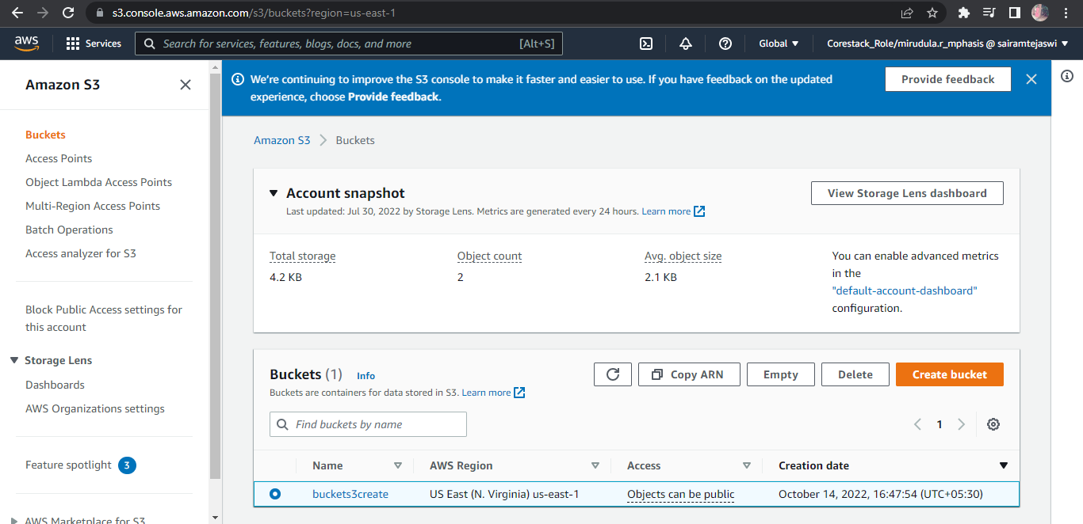

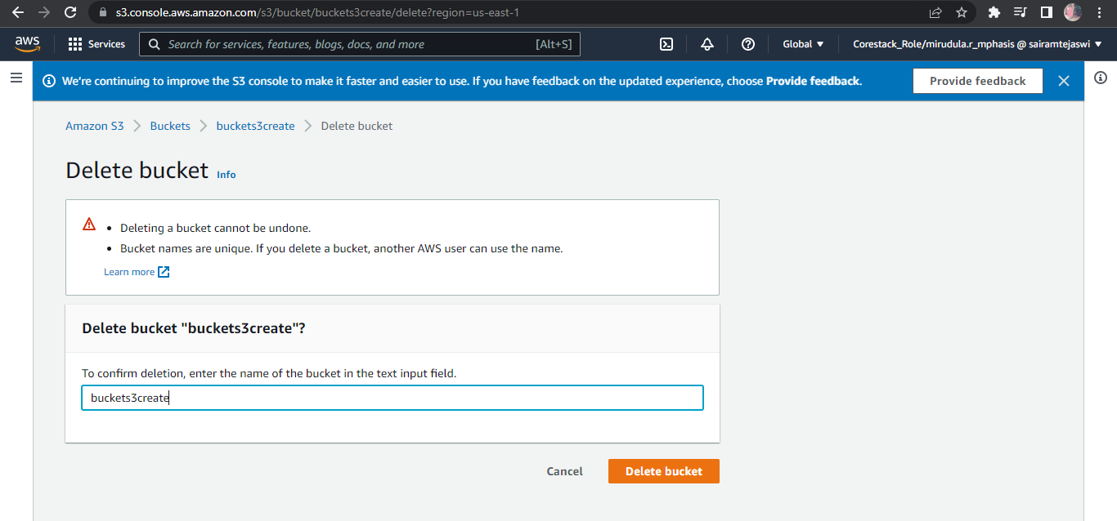

**Step 3.12.2:** Deleting the bucket

